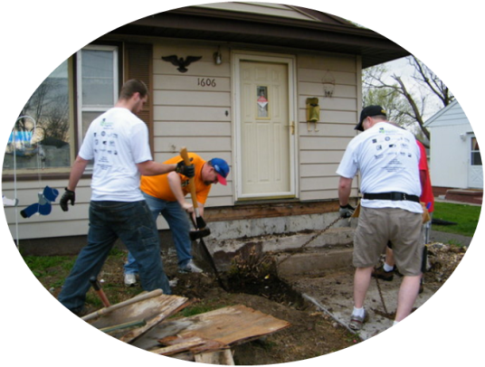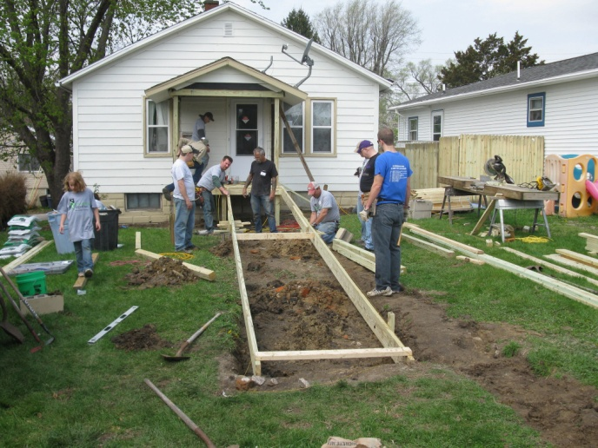

**rebuildingtogethermuscatine.org**

Rebuilding Together is the leading national non-profit working to preserve affordable home ownership and revitalize neighborhoods by bringing volunteers and communities together to rehabilitate the homes of low-income homeowners. These projects are accomplished through the hard work of more than 200 affiliates nationwide. In Muscatine County alone, over 36 homeowners have received assistance from hundreds of volunteers since our inception in 2007.